NAME: JAYANTH RAGAVAN M

COURSE: DATA SCIENCE (SELF PLACED)

BATCH: JULY-AUG

**Importing Libraries**

import numpy as np  
import pandas as pd  
import matplotlib as plt  
import seaborn as sns  
import plotly.express as px

df = pd.read_csv("../input/red-wine-quality-cortez-et-al-2009/winequality-red.csv")

**Understanding Data**

# See the number of rows and columns  
print("Rows, columns: " + str(df.shape))# See the first five rows of the dataset  
df.head()

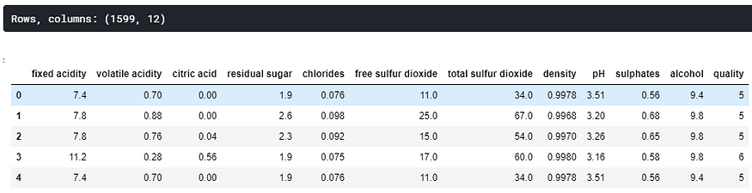

There are a total of 1599 rows and 12 columns. The data looks very clean by looking at the first five rows, but I still wanted to make sure that there were no missing values.

**Missing Values**

# Missing Values  
print(df.isna().sum())

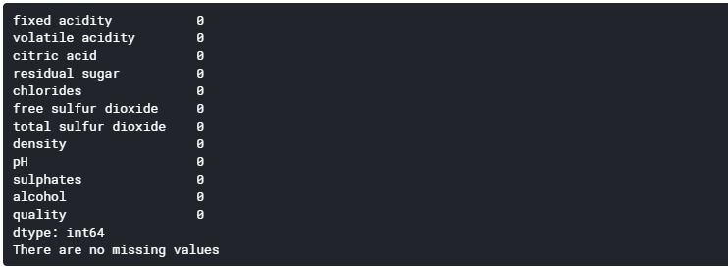

This is a very beginner-friendly dataset. I did not have to deal with any missing values, and there isn’t much flexibility to conduct some feature engineering given these variables. Next, I wanted to explore my data a little bit more.

**Exploring Variables**

**Histogram of ‘quality’ variable**

fig = px.histogram(df,x='quality')  
fig.show()

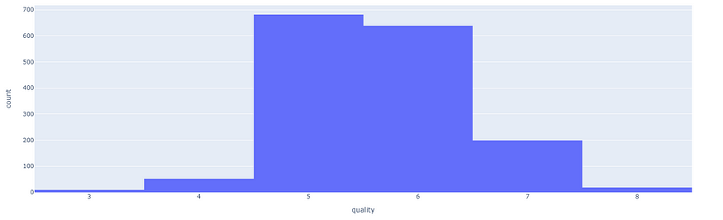

**Correlation Matrix**

corr = df.corr()  
matplotlib.pyplot.subplots(figsize=(15,10))  
sns.heatmap(corr, xticklabels=corr.columns, yticklabels=corr.columns, annot=True, cmap=sns.diverging_palette(220, 20, as_cmap=True))

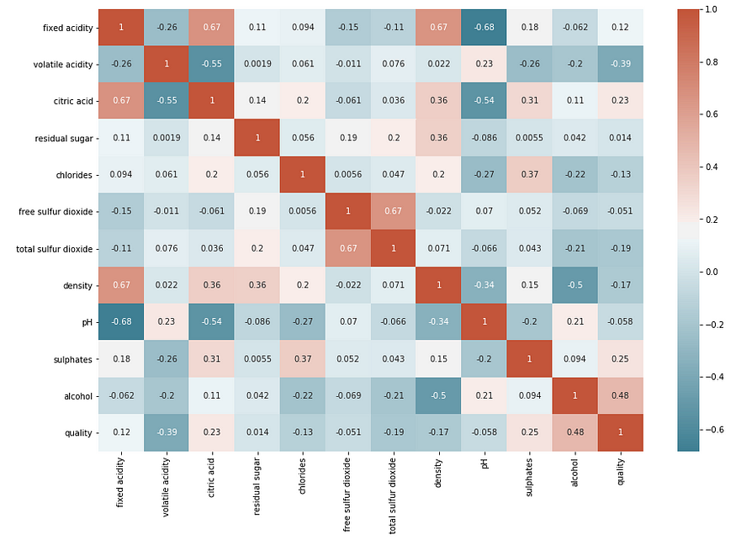

**Convert to a Classification Problem**

# Create Classification version of target variable  
df['goodquality'] = [1 if x >= 7 else 0 for x in df['quality']]# Separate feature variables and target variable  
X = df.drop(['quality','goodquality'], axis = 1)  
y = df['goodquality']

**Proportion of Good vs Bad Wines**

# See proportion of good vs bad wines  
df['goodquality'].value_counts()



**Preparing Data for Modelling**

**Standardizing Feature Variables**

# Normalize feature variables  
from sklearn.preprocessing import StandardScaler  
X_features = X  
X = StandardScaler().fit_transform(X)

**Split data**

# Splitting the data  
from sklearn.model_selection import train_test_split  
X_train, X_test, y_train, y_test = train_test_split(X, y, test_size=.25, random_state=0)

**Modelling**

**Model 1: Decision Tree**

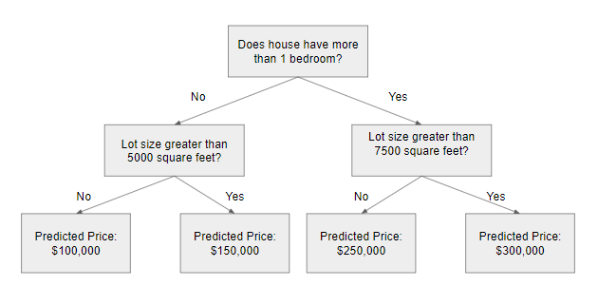

from sklearn.metrics import classification_report  
from sklearn.tree import DecisionTreeClassifiermodel1 = DecisionTreeClassifier(random_state=1)  
model1.fit(X_train, y_train)  
y_pred1 = model1.predict(X_test)print(classification_report(y_test, y_pred1))

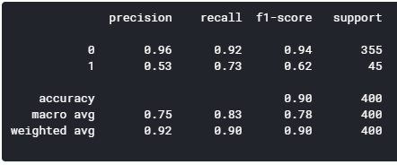

**Model 2: Random Forest**

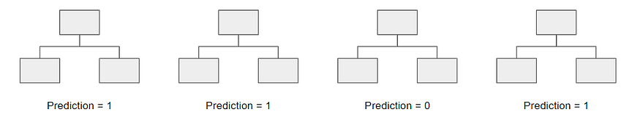

model2 = RandomForestClassifier(random_state=1)  
model2.fit(X_train, y_train)  
y_pred2 = model2.predict(X_test)print(classification_report(y_test, y_pred2))

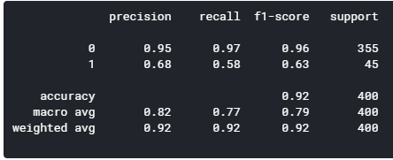

**Model 3: AdaBoost**

from sklearn.ensemble import AdaBoostClassifier  
model3 = AdaBoostClassifier(random_state=1)  
model3.fit(X_train, y_train)  
y_pred3 = model3.predict(X_test)print(classification_report(y_test, y_pred3))

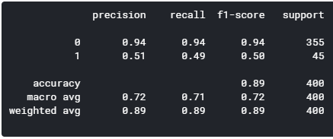

**Model 4: Gradient Boosting**

from sklearn.ensemble import GradientBoostingClassifier  
model4 = GradientBoostingClassifier(random_state=1)  
model4.fit(X_train, y_train)  
y_pred4 = model4.predict(X_test)print(classification_report(y_test, y_pred4))

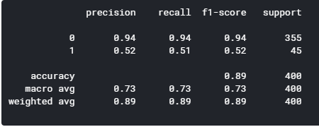

**Model 5: XGBoost**

import xgboost as xgb  
model5 = xgb.XGBClassifier(random_state=1)  
model5.fit(X_train, y_train)  
y_pred5 = model5.predict(X_test)print(classification_report(y_test, y_pred5))

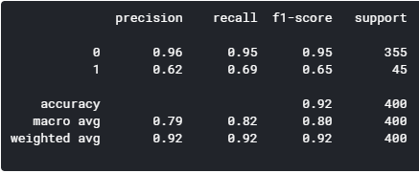

By comparing the five models, the random forest and XGBoost seems to yield the highest level of accuracy. However, since XGBoost has a better f1-score for predicting good quality wines (1), I’m concluding that the XGBoost is the winner of the five models.

**Feature Importance**

Below, I graphed the feature importance based on the Random Forest model and the XGBoost model. While they slightly vary, the top 3 features are the same: alcohol, volatile acidity, and sulphates. If you look below the graphs, I split the dataset into good quality and bad quality to compare these variables in more detail.

**via Random Forest**

feat_importances = pd.Series(model2.feature_importances_, index=X_features.columns)  
feat_importances.nlargest(25).plot(kind='barh',figsize=(10,10))

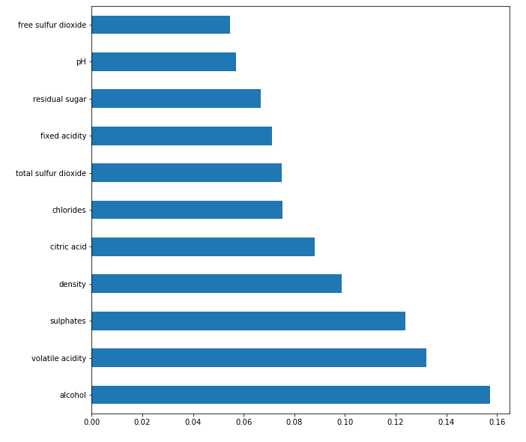

**via XGBoost**

feat_importances = pd.Series(model5.feature_importances_, index=X_features.columns)  
feat_importances.nlargest(25).plot(kind='barh',figsize=(10,10))

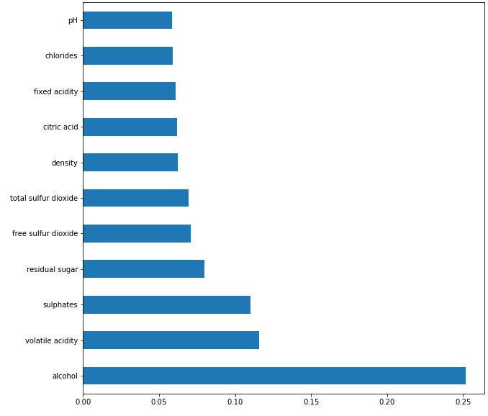

**Comparing the Top 4 Features**

# Filtering df for only good quality  
df_temp = df[df['goodquality']==1]  
df_temp.describe()# Filtering df for only bad quality  
df_temp2 = df[df['goodquality']==0]  
df_temp2.describe()

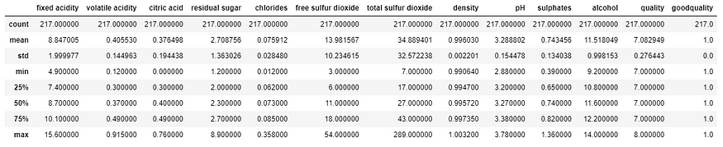

Good quality

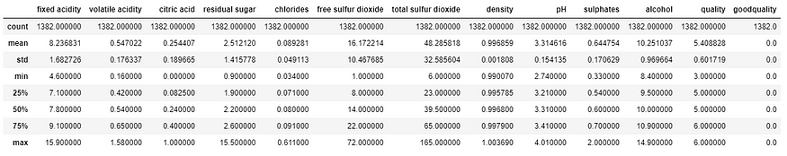

Bad Quality

**By looking into the details, we can see that good quality wines have higher levels of alcohol on average, have a lower volatile acidity on average, higher levels of sulphates on average, and higher levels of residual sugar on average.**